VAT Application

## Instructions

Instructions for “VAT Application”

**Please read and follow all the instructions for a proper use of the application!**

## Pre-requisites:

1. **VAT Declarations (D300)** –No modifications required.

1. **Trial Balance Template** – should be made using the imbedded file presented down below:



Simply map the information provided by the client onto the header. (Account, Description, Opening Balance (OB), Debit Movement (DM) & Credit Movement (CM) and Closing Balance (CB)). The header is also presented below:

|  |  |  |  |  |  |
| --- | --- | --- | --- | --- | --- |
| Account | Description | OB | DM | CM | CB |
| 401 | Vendors | 2.341 | 34.325 | 5.353 | 31.313 |

## Instructions:

1. After connecting to the platform, go to **VAT**:

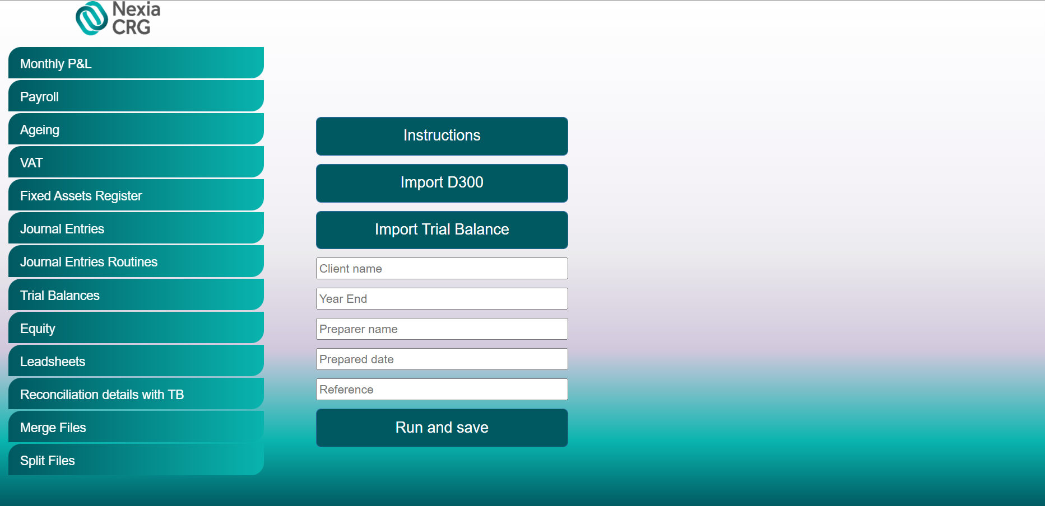

1. Click “Import D300” button and upload D300 declarations.
2. Click “Import Trial Balance” button and select the Trial Balance Template.
3. Enter the Client’s name, the period end (MM/DD/YYYY) of the audit (Year End), the Preparer’s name, Prepared date and Reference.
4. Click “Run and save”. Once clicking that, the robot will process your request and download the file in your designated downloads folder.
5. Finally, you should obtain an Excel document named “VAT test” + “client name”

**\*\*Note:** After obtaining the file, it will still require the Purchase Journals, Sales Journals and Monthly Trial Balances to be manually filled in the “**T10.1 VAT Test**”.

If you encounter any issues or if you have any other questions or suggestions, please contact:

Cristian Iordache, [cristian.iordache@ro.gt.com](mailto:cristian.iordache@ro.gt.com)

Bogdan Constantinescu, bogdanconstantinescu@ro.gt.com